* **Dictionary Type**

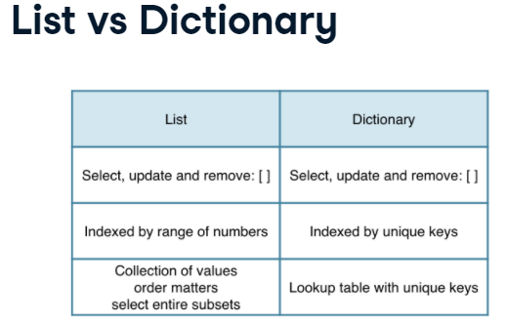

my_dict = {"key1":"value1", "key2":"value2"}

# Print out value that belongs to key 'norway'

print(**europe['norway']**)

# Print out the keys in europe

print(europe.keys())

#**Add** the country Sealand, which has 27 inhabitants

world[“sealand”] = 0.000027

#Update the population of Sealand (that’s already in the list)

world[“sealand”] = 0.000028

#Check if “italy” is in the list europe

print('italy' **in** europe)

# Remove Sealand from the list

**del**(world[“sealand”])

* Dictionaries can contain key:value pairs where the values are again dictionaries.

Example: Dictionary of dictionaries  
europe = { 'spain': { 'capital':'madrid', 'population':46.77 },

'france': { 'capital':'paris', 'population':66.03 },

'germany': { 'capital':'berlin', 'population':80.62 },

'norway': { 'capital':'oslo', 'population':5.084 } }

# To fetch the population for Spain from europe

europe['spain']*['population']*

# Create sub-dictionary data

data = {'capital':'rome', 'population':59.83}

# Add data to europe under key 'italy'

europe['italy'] = data